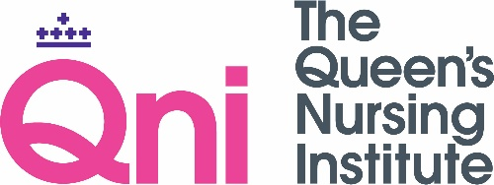
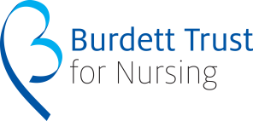

QNI Media Guidelines – Project Funding

Please mention the QNI and the Burdett Trust for Nursing in news interviews, in articles and in social media.

Develop your three key messages about your project that you can give in interviews.

Press Releases

We would be very glad if your organisation would issue a press release about your project or any significant news about your project. Please contact us if you would like us to provide a quote for the press release or if you would like us to check any details about the QNI.

Things to include in a Press Release

The Queen’s Nursing Institute is delighted to award funding to [NAME] for his/her new project to improve nursing care for people with a learning disability. We look forward to working with [NAME] and the other successful project leaders to deliver their ideas to deliver excellent healthcare in homes and communities over the coming year.
The Queen’s Nursing Institute is a registered charity founded in 1887. We campaign for the best possible nursing care for people at home and in the community. We work with nurses in England, Wales and Northern Ireland to ensure that excellent nursing is available to everyone, where and when they need it.

QNI Branding

Please remember to give full acknowledgement to the Queen's Nursing Institute in all publications, promotion and presentation material arising from Fund for Innovation through appropriate use of the Queen’s Nursing Institute logo and other branding, and:

- To ensure that any use of the Queen’s Nursing Institute branding complies with the branding guidelines as supplied by the Queen’s Nursing Institute’s Communications Department.

- To ensure that the Queen’s Nursing Institute has sight of and final approval of any and all artwork relating to the project prior to its production.

- To inform the Queen’s Nursing Institute of all requests for information from media personnel and to submit copies of articles or weblinks resulting from any media coverage of the project.

- To participate in other promotional activities as appropriate, for example presenting at conferences on behalf of the Queen's Nursing Institute events and to keep the QNI updated of any such activity.

You can download QNI logo by right-clicking on the logo above and saving it as a picture.

Social Media

Please follow the QNI is on Facebook, Twitter and Instagram. You can also follow Burdett Trust for Nursing on Twitter.

NMC guidance about social media: www.nmc.org.uk/standards/guidance/social-media-guidance.

Nursing Press

Please consider writing an article for a nursing journal. We can put you in touch with editors and comment on draft articles or ideas.

We hope that you would be willing to be an ‘expert contact’ for nursing press enquiries.

Photography

Please remember to get some photographic evidence of your project. If you would be willing to host a professional photographer for a session, please also let us know.

QNI Communications Contacts
Matthew Bradby, Head of Communications matthew.bradby@qni.org.uk
Hanna Mountford, Marketing and Administration Officer hanna.mountford@qni.org.uk
Joanna Sagnella, Publications Manager joanna.sagnella@qni.org.uk

