Looking After Your Wound

Helping to look after your own wound (or helping someone look after their wound) is likely to improve your quality of life and protect you from infection through reducing contact with others. Helping to look after your wound also helps others, by reducing pressure on the NHS.

We do not know if any particular type of dressing helps a wound heal faster. The most important thing is that the dressing used for your wound is comfortable and absorbent enough to prevent leaks.

Dressings can stay in place up to 7 days unless the dressing becomes loose, or leaks, or becomes uncomfortable (or you have been advised otherwise). Try to avoid getting the dressing wet.
This short video shows a dressing change
Prepare to change the dressing

- Clean the table or work surface you are going to put the new dressings on with sanitising wipes or a solution of warm water and detergent (washing up liquid).

- Wash your hands thoroughly with soap and water for 20 seconds, especially between fingers and palms of hands.
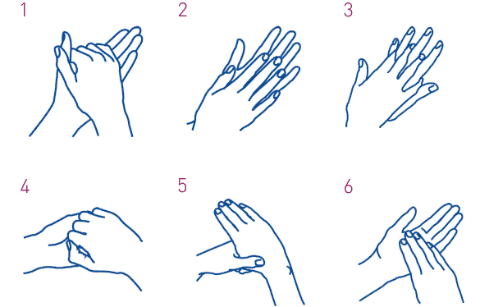
Dry hands with a clean towel/kitchen roll.
- Gather what you will need. This may include:
- A dressing pack or similar (typically contains gauze, gloves, tray, apron, waste bag)
- Dressing(s)
- Clean scissors (blades wiped with a sanitising wipe)
- Fluid to clean around the wound (tap water or saline)
- Cream for the skin around your wound
- Adhesive tape

- Prepare your materials
- Open dressing pack, put on apron (if you are not the patient) and put waste bag to one side
- Spread out the dressing pack wrapping so you have a clean surface.
- Open new dressing(s) and drop onto the clean surface of the dressing pack wrapping
How to remove the old dressing

- Carefully remove the old dressing without touching the part that been in contact with the wound or touching the wound itself.
- If the dressing is stuck, soak with water or saline and wait for the dressing to loosen – allow a bit of time and avoid pulling as this will be painful and will damage the wound
- If the dressing is adhesive or has an adhesive border, avoid peeling it off. Instead, lift one or more corners of the dressing and stretch it horizontally along the skin surface to break the adhesive bond. Again, take your time and continue gently stretching until the entire dressing lifts.
- Place the dirty dressing in the waste bag and wash your hands.
How to clean the wound and apply a new dressing
- If you have sterile or clean gloves, put them on. If not, try to avoid touching the wound or anything that will be in contact with the wound.

- If you want to clean the wound itself, clean from the centre outwards using tap water (or saline) and gauze from the dressing pack. Clean the skin around the wound.

- Make sure the skin around the wound is dry. If your health care professional advises, apply cream to the skin around the wound but avoid where any adhesive tape or dressing will go, or it will not stick.

- Put the new dressing on the wound following the instructions that came with the dressing.

- Clear up, put sealed waste bag in bin and wash your hands. (The waste bag can go in your usual rubbish collection unless you have been advised otherwise.)
Be aware of what is happening with the wound

Monitor for signs of infection or other problems:

- More wound leakage than usual
- More pain than usual
- Increasing redness around the wound
- An unusual smell
- Wound is getting bigger
- Feeling generally unwell

Contact your health care professional or NHS 111 if you are worried.

- Who should I contact if I am worried?
Useful Information
If you have any concerns about your wound or dressing supplies, contact your GP surgery or community nursing service
Important Contact Numbers
GP Surgery:
Community Nursing:

- Where do I get more dressings from?
Your dressings will be supplied by ………………………………………
You are responsible for asking for more dressings as they begin to run out. Some items may need a prescription, please speak to your health care professional about this.

- How can I tell if my wound is improving or getting worse?
One way to keep a record of your wound healing is to take a photo. If you want to do this, you need:
- A digital camera or mobile phone with a camera.
- To be able to see the wound site easily and safely.

These tips will help:
  - Use the automatic settings on your camera and use something plain as a background. If possible, include a ruler in the photo.
  - Make sure you are comfortable and there is plenty of light.
  - Make sure that the photo will only show parts of your body you are comfortable showing. Avoid photographing any identifying marks such as your face, tattoos or birthmarks.

Providing the tap water is drinkable, it does not need to be boiled.

