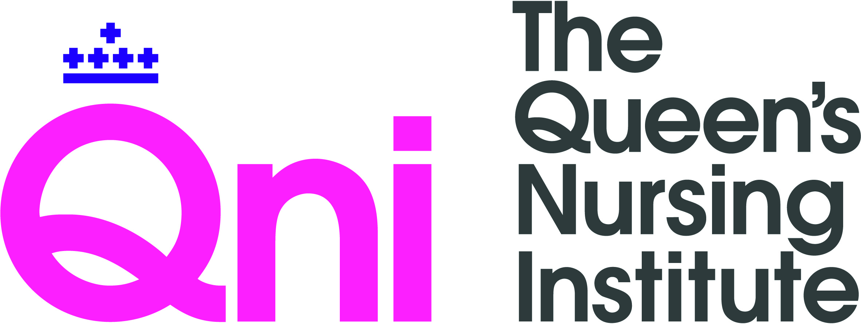
Community Nursing Covid-19 Innovation/Best Practice Template
We are interested to gather examples of new practice in community and integrated healthcare services as they have adapted to the regulations and clinical requirements of the Covid-19 pandemic. We seek to share examples of practice to help promote learning and to drive improvements across the sector and we may contact you for further information.
Please type and expand the text boxes as needed.
Personal Information
- Name:
- Job title:
- Employer:
- Email address:

- Please describe your practice innovation (500 words or less).

- How has this enabled you to treat/support patients/residents/families/carers more effectively and safely?
- How has this enabled you to work more effectively with colleagues/partner organisations?

- Do you see this new way of working as a temporary adaptation to current conditions, or a permanent/evolving change?

- Please describe any particular challenges you had to overcome.

- Please describe any continuing challenges you would like to address.

- Please list any websites, online platforms or apps that have helped you.

- What are the main pieces of IT or other equipment you need (e.g. digital camera, phone, laptop, iPad).

- Please give any individual examples, quotes or other information.

- Please email any images, ideally as separate files.

Thank you for sharing your experiences and insights with us. We will contact all those who submit a case study to us. We intend to publish selected case studies on the QNI website and print media, but will only do this with your consent.
Your personal details will be handled in conformity with data protection regulations and will not be shared with any third party without your consent.
Please contact Matthew Bradby, Head of Communications, with any queries: matthew.bradby@qni.org.uk .

The Queen’s Nursing Institute
www.qni.org.uk
June 2020

