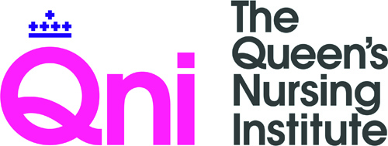 | 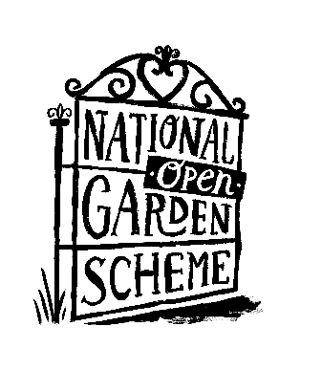

The NGS Elsie Wagg (Innovation) Scholarship 2022

Application form

Closing date: 29th October 2021 at 5pm

Guidance notes accompany this application. Please make sure that you have read this before completing the application form to ensure that your project meets the required criteria.

Please ensure that you complete all sections of the application form and submit an electronic copy (in WORD document format) of your application to Aga Kusmierz, Practice Development, Events and Finance Administrator, aga.kusmierz@qni.org.uk

If you have any queries or would like to talk through your project idea before commencing or submitting an application, please contact Sue Boran, Director of Nursing Programmes (Innovation) by email sue.boran@qni.org.uk

Check list: Please answer the questions below to confirm you are ready to submit your application | Please tick
Have you read the guidance notes?
Have you completed all questions and sections of the application form?
Have you attached a letter of support from your direct line manager that must include the following information:
- The direct line manager’s contact details
- Confirmation that you have had an enhanced check with adult’s /child’s barred list check through the Disclosure and Barring Service (DBS)
- Confirmation that your employing organisation has safeguarding policies in place for children, young people and vulnerable adults
- Permission for you to have time to undertake the work of the project including three two-day workshops at the QNI in London.

Is your project based within England, Wales, Northern Ireland, Channel Islands and Isle of Man only?

The Elsie Wagg (Innovation) Scholarship 2022

About you

 | Our questions |  | Your answers
1 | Full Name  (this should be the nurse with lead responsibility for delivering this project (if successful) and the main contact person)
2 | Email address  (please make sure this is one which is regularly checked)
3 | Phone numbers including mobile  (please make sure this is one which is regularly used)
4 | Address for correspondence
5 | Please sign here to confirm that you give consent for The QNI to use the information provided above for the purpose of this application.
6 | Personal statement in support of your application.  Please answer the questions below.
6a. | Why are you the right person to lead a QNI innovation project? (maximum 250 words)
6b | What skills and experience do you have that you can apply to project leadership?  (maximum 250 words)
7 | Current job title and date started
8 | List your two previous job titles and organisations with dates
9 | NMC registration number
10 | List your educational and professional qualifications with years obtained

Your Co-lead (if applicable)

11 | Project Co-lead – Name and job title
12 | Project Co-lead - Email address
13 | Project Co-lead - Phone number
14 | Please sign here that you obtained their consent for The QNI to use the information provided above for the purpose of this application.

About your organisation

 | Our questions | Your answers
15 | Organisation - Name
16 | Organisation - Address
 | Direct line manager supporting the application | Your answers
17 | Name
18 | Address
19 | Email
20 | Phone number
Please note that if you are successful with your application, you must inform us of any changes to details on this application form as soon as possible

Your project overview

21 | What is the name of your project?

22 | What is the overall aim of your project? (maximum 100 words)  Show how the project will improve health and well-being outcomes through gardens and gardening for people in the community.

23 | Why is your project needed?  Include a review of relevant information and evidence of the need.

24 | What makes your project innovative?  Show what is new, exciting or different about the project

25 | How will your project contribute towards any local / national targets for improving health and wellbeing outcomes?  Link the project idea to national and local policies and strategies

Your project plan

26 | What are your three key project objectives (improving health and well-being outcomes for people in the community through gardens and gardening) Include SMART objectives (Specific, Measurable, Achievable, Realistic, Timely).

27 | What will be your key activities to achieve success within this given time frame?  It is expected that projects will be undertaken and completed between 1st March 2022 and 1st March 2023
March 2022 – May 2022
June 2022 – August 2022
September 2022 – November 2022
December 2022– February 2023

28 | How will you measure your progress?

29 | How do you plan to evaluate your project?

30 | What challenges do you anticipate and what is your plan to overcome them?

31 | How will you involve individuals, familes, carers and communities in the project?

32 | How will your colleagues support your involvement in the project?

33 | How will other professionals, organisations and services be involved in delivery?  Include support from other health and care professionals and organisations.

34 | Is ethical approval required?  If ethical approval is required there must be evidence that this is being sought. Funding will not be given to successful applications until approval has been confirmed.

Project outcomes and dissemination

35 | What are the health and/or wellbeing outcomes you want to achieve?

36 | How many people do you hope this will reach (approximate numbers)?

37 | How will access to healthcare for people supported through this project in the community improve?

38 | What will you need to do to make your project sustainable after the QNI funding period ends?

Project budget

 | Our questions | Your answer
39 | How much project funding do you require? (The maximum is £5000) | £

40 | What will you spend the project funds on?  Realistic and detailed breakdown of costs (or estimates) must be included. Any other sources of funding obtained should be clearly identified, including from your employer.  Please ensure that your project budget includes £600 allowance for travel and/or accommodation in order to attend the professional development workshops in London (if applicable).
 | Key budget item | Estimated cost
 | Travel and/accommodation allowance | £600

41 | Where did you hear about the QNI Fund for Innovation programme?
42 | Where did you hear about The National Garden Scheme?

Please ensure that you complete all sections of the application form and send an electronic copy (in Microsoft Word document format) to aga.kusmierz@qni.org.uk

Data protection statement
Your privacy is important to us, and we will NOT pass your details to any third party. The Queen's Nursing Institute will use the information provided on the application form to process the proposal and manage any grant awarded. The information on your application will be shared with QNI internal assessors and one external assessor associated with our Institute. By providing us with your information, you consent to us using it for the purposes outlined above.

