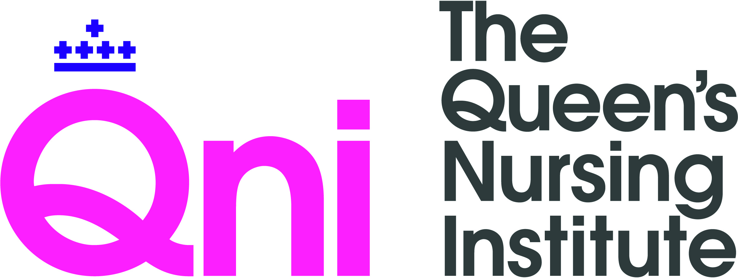

Community Nursing Innovation Project

Project title:

Final report and impact value measurement

Purpose

The purpose of the final report is to answer the following questions:

- What did you learn while undertaking the project?
- What were your key activities?
- What were you key outcomes?
- What difference did you make for people?
- How well did you involve people with a learning disability in this work?

The report will enable the dissemination of your work and successful completion will prompt the release of the final payment from the QNI. It should support you to communicate the value of your project to your employing organisation and other potential funders, and help you to consider next steps for refining and developing your project. It should be a reflective but informative account of both your professional development and the development of the work within the project.

Please complete every box.

As this is a word document, the table will expand to accommodate more text. Please type your responses.

1 | Project title
2 | Name of project lead
3 | Name of co-applicant(s)
4 | What was the overall aim of your project?  Has this altered as the project developed?
5 | Please provide a brief summary of the project
6 | What were the key outcomes?
7 | Briefly describe your experience of implementation: what changes if any had to be made?
8 | Please complete the following information on the three specific aims agreed at the beginning of the project year, using information from the planning triangle and monitoring framework.  Specific Aim 1  - What outcomes were achieved?  - Which outcome indicators did you use?  - Looking at the outcome, on a scale of 1 to 5, how far do you feel you achieved the specific aim? (5 = fully; 4 = mostly achieved 3 = moderately achieved; 2 = partly achieved; 1 = not at all)
9 | Specific Aim 2  - What outcomes were achieved?  - Which outcome indicators did you use?  - Looking at the outcome, on a scale of 1 to 5, how far do you feel you achieved the specific aim? (5 = fully; 4 = mostly achieved 3 = moderately achieved; 2 = partly achieved; 1 = not at all)
10 | Specific Aim 3  - What outcomes were achieved?  - Which outcome indicators did you use?  - Looking at the outcome, on a scale of 1 to 5, how far do you feel you achieved the specific aim? (5 = fully; 4 = mostly achieved 3 = moderately achieved; 2 = partly achieved; 1 = not at all)
11 | Apart from your intended outcomes, what other unexpected outcomes happened as a result of your project?
12 | Has access to healthcare improved for people helped by the project?  If so, how? If not, why not?  Has there been a wider impact locally?
13 | Do people who have been helped by the project, report better quality of life and wellbeing as a result or their involvement in the project?  Has there been a wider impact locally?
14 | How much user involvement has there been in your project?  Please give examples of how involvement was facilitated.  Did you find it a positive experience?
15 | What have been the challenges in delivering your project?  Reflect on problematic situations/changes. Discuss unforeseen or unscheduled events that have been encountered and how they were addressed
16 | Have there been any changes to the personnel involved in the project?  Explain the background to any changes and how this impacted the project
17 | What have been the positive benefits either personally or professionally in the undertaking of this project?  How have your leadership skills developed?
18 | Please provide or attach a full financial statement.  Detail how project funds were spent.  Use of money left over on completion of the project must be discussed and agreed with the Queen's Nursing Institute Director of Nursing Programmes
19 | Please provide details of how you have you promoted your project?  Through articles, formal and informal presentations, interviews, etc.
20 | What do you feel have been the outstanding achievements of the project to date?
21 | What will happen to your project now? Is it sustainable, has the employing organisation agreed to fund further work?
22 | What did the QNI do well to support you?
23 | What can the QNI do to improve its support to nurse project leaders in the future?
24 | What advice would you give to other nurses starting an innovation project?
25 | Do you have any final comments?

Please also complete the impact value measurement on the following page.

MEASURING IMPACT

The Charity Commission’s new SORP (Statement of Recommended Practice) requirements are asking charities not just to report on how we spend our money but also to illustrate the ‘impact’ we have on clients.

(Some of the questions below will not apply to your area of work or the data may not be available – please complete as much as you can of the following)

How many people were in the project team?

How many healthcare professionals were involved in the work of the project in total, even if they aren't named in the application?
How many people/clients were directly involved as beneficiaries of the project?
How many carers (i.e. non-professionals, such as family or friends) were involved as beneficiaries of the project?
What would the cost per person/client be if the work developed through the award was adopted as permanent practice (in terms of money and time)?
What would be the savings (if any) per person/client (money and time)?
How many people, nationally, have the condition or are in the situation that the award seeks to treat/improve/monitor?
Please include a case study of how this project made a difference
Please send your report by email to sue.boran@qni.org.uk

