**Continence Screening Tool**

**Name**

**DOB**

**NHS No. (if known)**

**To be completed by Patient or someone on their behalf (Carer, Partner, HCA, RN)**

**AND**

**3 day bladder diary to be given and completed for urine problems**

**OR**

**Bowel diary to be completed for bowel problems only**

**Are you receiving Hartmanns continence products on Home delivery? Yes/No**

**1) Do you have any symptoms of urinary tract infection? (please tick all that apply)**

* Pain on passing urine (Dysuria)
* Temperature if taken above 1.5C above normal, to be taken twice in the last 12 hours.
* New symptoms of urgency and frequency.
* New symptoms of incontinence,
* New onset of confusion, difficulty making decisions
* New lower abdominal pain.
* Offensive smelling urine.
* Visible blood in urine.

**How long have you had these symptoms?**

**If more than three days please ring GP and provide urine sample (mid stream, if possible)**

|  |
| --- |
| Date Urine Specimen sent to GP: |

**2) Do you have any long term conditions e.g. Diabetes, MS, Parkinsons, spinal injury, enlarged Prostate, Cancer of any kind, prolapse, Stroke or any Bladder or Bowel conditions? Do you have any problems with sight?**

|  |
| --- |
| Provide details |

**3) Do you smoke (Yes/No) or are you an ex-smoker? (Yes/No)**

**4) Do you have problems making decisions or coordination of simple tasks in the home? (e.g. Dexterity)**

|  |
| --- |
|  |

**5) Home Situation**

Type of accommodation e.g house or bungalow?

Can you walk up and down the stairs independently? Yes/No

Can you access toilet facilities independently? Yes/No

Do you have any mobility problems or any walking aids? Yes/No

Do you have carer support day to day? Yes/No

|  |
| --- |
| Provide details |

**6) What do you like to eat and drink each day?**

|  |
| --- |
| Provide details |

**7) Do you have any concerns or soreness of your skin around the genital area?**  Yes/No

|  |
| --- |
| Provide details |

**8) Are you taking any of the following medications?**

These medications affect bladder & bowel function (please tick)

* Alphablockers e.g. Tamsulosin, or Finasteride;
* Anticholinergic e.g Solifenacin, Tolterodine, Oxybutynin, Mirabegron;
* Antidepressants;
* Oestrogen, patches, gel, pessaries;
* Water tablets e.g Furosemide; Spironolactone, Bumetanide
* Laxative e.g Laxido, Movicol, Senna, Lactulose, Fybogel, Docusate, Bisacodyl;
* Pain relief e.g Co-Codamol, Morphine, Tramadol;
* Sedatives e.g Diazepam, Lorazepam, Clonazepam;
* Recreational drugs?

**9) Are you allergic to anything? Yes/No**

|  |
| --- |
| Provide details |

**10) Are you experiencing bladder problems?**  Yes/No

**11) Are you experiencing bowel problems only?** Yes/No

**12) In what way does the bladder or bowel problem affect your life?**

|  |
| --- |
|  |

If experiencing problems with both, complete questionnaire. If bowel problems only go to question 17

OR

**Complete the following questions below and tick all that apply:**

# 13) Stress Bladder Symptoms.

* Urine leaks when coughing, sneezing or doing exercises or during sexual intercourse.
* Problem may have existed for some time before help sought.
* Problem may be worse at different times of the monthly cycle, if applicable.
* Problem may have become worse following the menopause.
* Males’ only, recent prostatectomy?

**14) Frequency/Urgency Bladder Symptoms**

* Always wanting to go to the toilet, over 6/8 times a day.
* Needs to know where toilet is.
* May be wet before the toilet is reached.
* Anxiety about the problem/habit.
* May drink mostly tea/coffee/alcohol/fizzy drinks or may not drink sufficient.
* May have to get up more than twice a night to pass urine.
* May be wet again after going to the toilet.
* May have a history of stroke/diabetes/MS/surgery in pelvic or spinal area/early stages of dementia/behavioural problems/other neurological conditions.
* May have urinary tract infection see above for symptoms

## 15) Overflow symptoms/bladder not emptying

* Symptoms may appear similar to stress and urge.
* Urine stream not as fast as previously.
* Difficulty or hesitancy to pass urine.
* May not be able to pass urine at all.
* Bladder may occasionally empty without warning.
* May have an enlarged prostate gland, urethral stricture or out flow obstruction, if known
* May have a history of recurrent urinary tract infection.
* May have a history of constipation.

### 16) Functional Loss/Reflex

* Have no idea when urine is to be passed or bowels opened.
* Bladder or bowel fills and empties with very little warning.
* Does not have opportunity to sit on the toilet.
* May be terminally ill or extremely sedated.
* May only be a night time problem/nocturnal enuresis.

**17) Bowel Symptoms/Faecal Incontinence**

Complete bowel diary and refer to Bristol Stool Chart (back of form)

* Bowels moved less than 3 times a week.
* Urgency.
* Faecal incontinence.
* Smearing.
* Recent changes in bowel habit.
* Blood/mucus visible.
* Any recent weight loss.
* Family history of bowel problems.
* Pain/discomfort on having bowels opened.
* Feeling of incomplete bowel emptying.
* Stool type (Bristol Stool Chart) record score (1-7).
* Unable to sit in correct position on toilet/commode.
* Unable to recognise or have opportunity to have bowels opened.
* Anxiety about the problem.
* Do you perform digital removal of faeces?
* Please provide examples of what you eat and drink. Do you eat fruit and vegetables?

|  |
| --- |
| Provide details |

**Thank you for completing the Screening Tool**

Your Nurse/Carer will arrange to collect this completed form from you, review your responses and discuss any further action with you.

**If further advice or support is required please contact the Bladder and Bowel Team via SPA 01904 721200**

**BOWEL FREQUENCY CHART**

**Name Date of Birth:**

**NHS No:**

|  |  |  |  |
| --- | --- | --- | --- |
| **Date** | **Time** | **Type of Stool**  **(Bristol Scale)** | **Comments/Additional Information**  **Any leakage? What time?** |
|  |  |  |  |
|  |  |  |  |
|  |  |  |  |
|  |  |  |  |
|  |  |  |  |
|  |  |  |  |
|  |  |  |  |
|  |  |  |  |
|  |  |  |  |
|  |  |  |  |
|  |  |  |  |
|  |  |  |  |
|  |  |  |  |
|  |  |  |  |
|  |  |  |  |
|  |  |  |  |
|  |  |  |  |
|  |  |  |  |
|  |  |  |  |

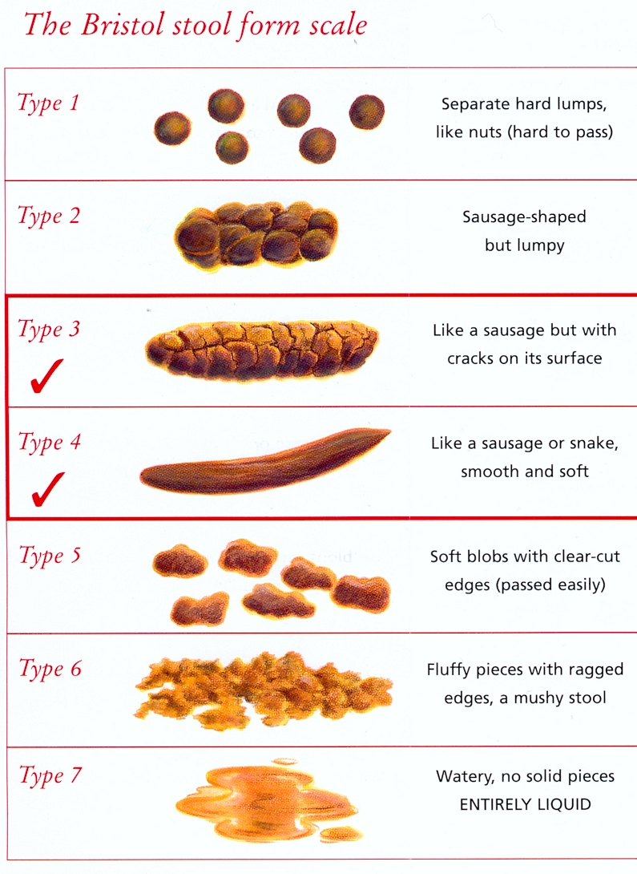

FREQUENCY / VOLUME CHART

Name: Date of Birth:

NHS No:

Please see instructions on the back of this page.

|  |  |  |  |  |  |  |  |  |  |
| --- | --- | --- | --- | --- | --- | --- | --- | --- | --- |
| **Date Commencing and Time** | **Day 1** | | | **Day 2** | | | **Day 3** | | |
|  | In | Out | Wet | In | Out | Wet | In | Out | Wet |
| **6 am** |  |  |  |  |  |  |  |  |  |
| **7 am** |  |  |  |  |  |  |  |  |  |
| **8 am** |  |  |  |  |  |  |  |  |  |
| **9 am** |  |  |  |  |  |  |  |  |  |
| **10 am** |  |  |  |  |  |  |  |  |  |
| **11 am** |  |  |  |  |  |  |  |  |  |
| **12 noon** |  |  |  |  |  |  |  |  |  |
| **1 pm** |  |  |  |  |  |  |  |  |  |
| **2 pm** |  |  |  |  |  |  |  |  |  |
| **3 pm** |  |  |  |  |  |  |  |  |  |
| **4 pm** |  |  |  |  |  |  |  |  |  |
| **5 pm** |  |  |  |  |  |  |  |  |  |
| **6 pm** |  |  |  |  |  |  |  |  |  |
| **7 pm** |  |  |  |  |  |  |  |  |  |
| **8 pm** |  |  |  |  |  |  |  |  |  |
| **9 pm** |  |  |  |  |  |  |  |  |  |
| **10 pm** |  |  |  |  |  |  |  |  |  |
| **11 pm** |  |  |  |  |  |  |  |  |  |
| **12 midnight** |  |  |  |  |  |  |  |  |  |
| **1 am** |  |  |  |  |  |  |  |  |  |
| **2 am** |  |  |  |  |  |  |  |  |  |
| **3 am** |  |  |  |  |  |  |  |  |  |
| **4 am** |  |  |  |  |  |  |  |  |  |
| **5 am** |  |  |  |  |  |  |  |  |  |
| **Totals** |  |  |  |  |  |  |  |  |  |

I cup = approximately 150mls 1 beaker = approximately 200mls

**IMPORTANT - Please read this carefully**

* It is very important that you fill in the chart.
* It is designed to give us an idea of your average fluid intake, urine output and leakage. This assists us greatly in the diagnosis of your condition.
* For each day record how much you drink (metric i.e.mls if possible) and when you drink it (put the volume in the square provided for that time). If you often drink from the same or similar cups, then you need only measure how much it holds once and put that value down every time you drink from it.
* When you go to the toilet, measure the urine you pass using a small jug. If possible record the volume in mls rather than fluid ounces, and again record it in the box next to the nearest hour.
* Every time you leak put a cross in the column marked "Wet".
* When you go to bed put a line on the chart next to the right time, so that we can tell how many times you have to get up in the night to pass water.
* Below is an example of a correctly completed section.

|  |  |  |  |
| --- | --- | --- | --- |
| Time | Day 1 Monday | | |
|  | In | Out | Wet |
| 6 am |  |  |  |
| 7 am | 100 |  | X |
| 8 am |  | 300 |  |
| 9 am |  |  |  |
| 10 am |  | 290 |  |
| 11 am | 250 |  |  |
| 12 noon |  |  | X |
| 1 pm | 400 |  |  |